**Assignment 7.4**

**Write a word count program using partitioner and implement the following logic in the partitioner words with length 5 should go into reducer 1 and words with length 6 should go into reducer 2 and the rest of the words should go into reducer 3.**

**Sample Input:**

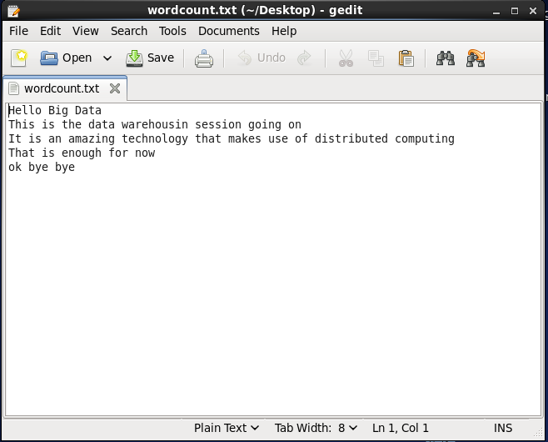

**Driver class:**

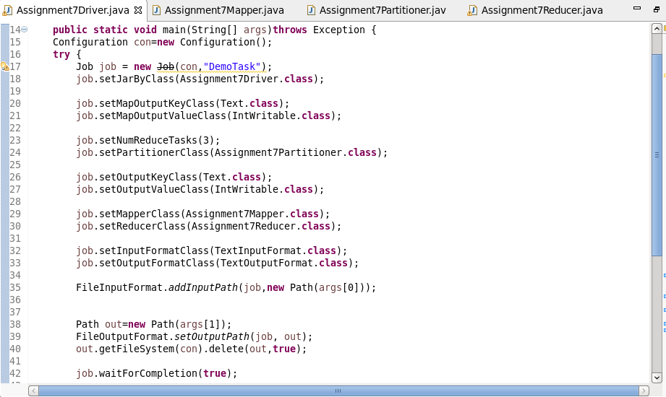

**Mapper class:**

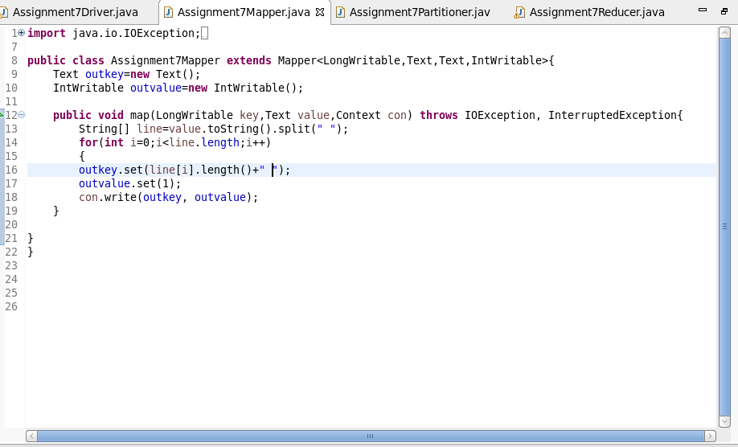

**Partitioner class:**

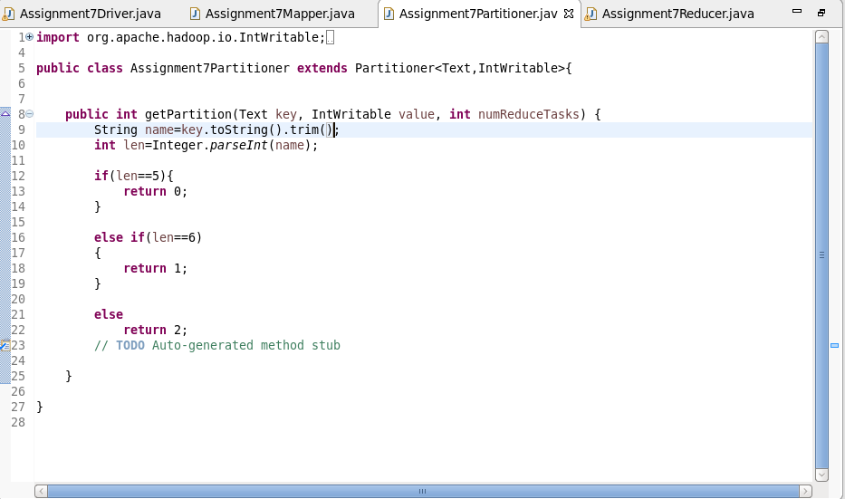

**Reducer class:**

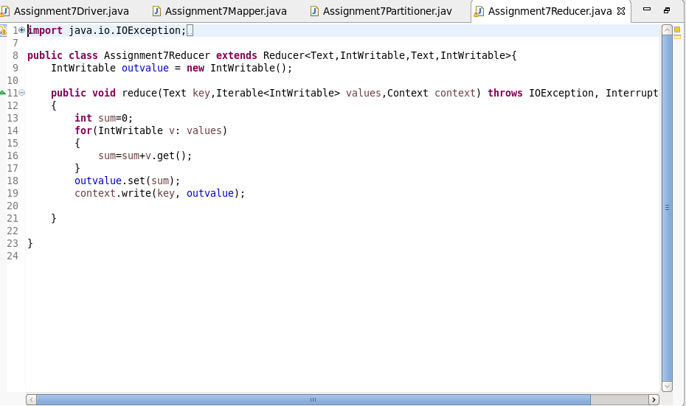

**Output:**

